**User Journey**

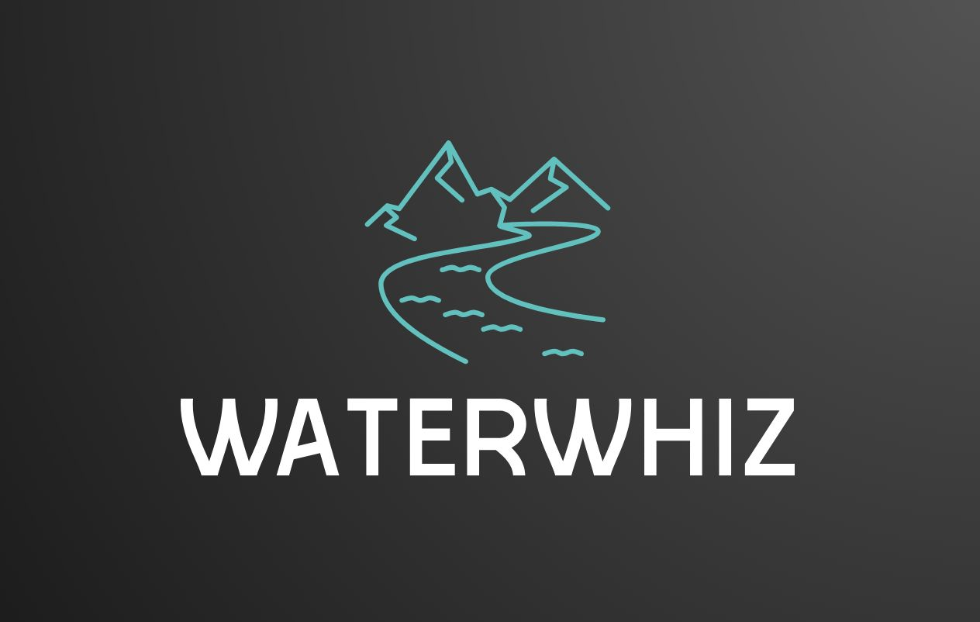

**Team: TP31**

**Table of Contents**

**1.0 Visualising the Journey** **3**

**2.0 Mapping the Journey** **3**

User Journey Map for WaterWhiz 3

1. Homepage 4

2. Activity Planning 4

3. Trends 4

4. Chatbot 4

5. Catchments 4

6. Runoff Estimation 5

7. Education 5

**3.0 Insight Mapping** **5**

# 1.0 Visualising the Journey

# 2.0 Mapping the Journey

## User Journey Map for WaterWhiz

### **1. Homepage**

* User arrives: The user lands on the homepage.
* Problem awareness: The user understands the problem of stormwater pollution.
* Call to action: The user clicks the main call to action button to proceed to the activity planning page.

### **2. Activity Planning**

* User navigates: The user arrives at the activity planning page.
* Safety standards: The user sees recommended safety standards for outdoor activities based on pollution levels.
* Activity planning: The user plans activities based on pollution levels in nearby water bodies.
* Health risks and prevention: The user learns about health risks and preventive measures for outdoor activities.
* Trends page link: The user clicks the link to navigate to the trends page.

### **3. Trends**

* User navigates: The user arrives at the trends page.
* Pollution trends: The user views pollution trends in water bodies over the past 5 years and predictions for the next month.
* Informed decisions: The user makes informed decisions based on the trends data.
* Chatbot link: The user clicks the link to navigate to the chatbot page.

### **4. Chatbot**

* User navigates: The user arrives at the chatbot page.
* Query: The user asks questions about water quality or requests activity planning.
* Response: The chatbot provides answers or suggestions.
* Catchments link: The user clicks the link to navigate to the catchments page.

### **5. Catchments**

* User navigates: The user arrives at the catchments page.
* Water quality: The user views water quality for different regions in Victoria.
* Pollution levels: The user identifies highly polluted and less polluted zones.
* Suburb analysis: The user understands the pollution levels in different suburbs.
* Call to action: The user clicks the call to action button to navigate to the runoff estimation page.

### **6. Runoff Estimation**

* User navigates: The user arrives at the runoff estimation page.
* Estimation: The user estimates their household's contribution to pollution.
* Insights: The user receives tailored insights on their pollution impact.
* Call to action: The user clicks the call to action button to navigate to the education page.

### **7. Education**

* User navigates: The user arrives at the education page.
* Learning: The user learns about reducing their pollution impact.

# 3.0 Insight Mapping

**1. Homepage**

Insight: Users become aware of the issue of stormwater pollution and its impact on waterways. The homepage sets the stage by explaining how small actions by individuals contribute to a larger environmental problem. This page highlights the importance of addressing pollution and encourages users to take action by exploring more features of the website.

**2. Activity Planning**

Insight: Users can plan outdoor activities like swimming or fishing by understanding the current pollution levels in nearby water bodies. The page provides safety recommendations to ensure users can make informed choices about engaging in outdoor activities, minimizing their health risks based on real-time data. Users are empowered with knowledge of how water quality affects recreational activities.

**3. Trends**

Insight: The trends page offers a deeper understanding of pollution patterns over time. Users can see historical data and predictions, allowing them to see how pollution levels fluctuate and what may cause increases or decreases. This knowledge enables users to make data-driven decisions about when to engage in outdoor activities or how to reduce their own pollution footprint.

**4. Chatbot**

Insight: The chatbot provides instant answers to questions related to water quality or activity planning. It offers personalized assistance, which is particularly useful for users seeking quick recommendations. This interaction makes the website more user-friendly and accessible, helping users find specific information without needing to search manually.

**5. Catchments**

Insight: This page gives users a regional view of water quality and pollution levels across various catchments. By understanding which areas are more affected by pollution, users can get a clearer picture of the geographical disparities in water quality and target their pollution reduction efforts accordingly. It also fosters a sense of accountability toward their local environment.

**6. Runoff Estimation**

Insight: This tool allows users to estimate their household’s contribution to stormwater pollution. By seeing a personalised estimate of their runoff, users can become more aware of their individual impact. The page provides tailored insights and actionable steps, empowering users to take control of their pollution footprint.

**7. Education**

Insight: This page educates users on practical ways to reduce their contribution to pollution. It provides actionable tips and best practices for proper waste disposal, reducing runoff, and minimising environmental harm. This final step solidifies the user’s role in making a positive environmental impact and encourages continuous improvement in their behaviours.

Each page builds upon the user’s awareness, offering them progressively more detailed insights into pollution, water quality, and their own responsibility in reducing environmental harm. The journey moves from learning to action, ensuring users are not only informed but motivated to make changes.